

Laxman Dutt Degala | CS5590BD | June 17, 2014

Lab 1 Assignment

**Tasks 1:**

Group report has already been submitted.

**Task 2:**

1. Have already installed virtualbox, winscp and putty, but I am using the cloudera image which I downloaded.
2. Cloudera Server

Cloudera image has been created for the previous project.

Have cross checked to see if the image is working fine. Entire eco system looks fine, have run mapreduce for wordcount once again.

1. WordCount exercise:

Folder where WordCount data and jar file is present.

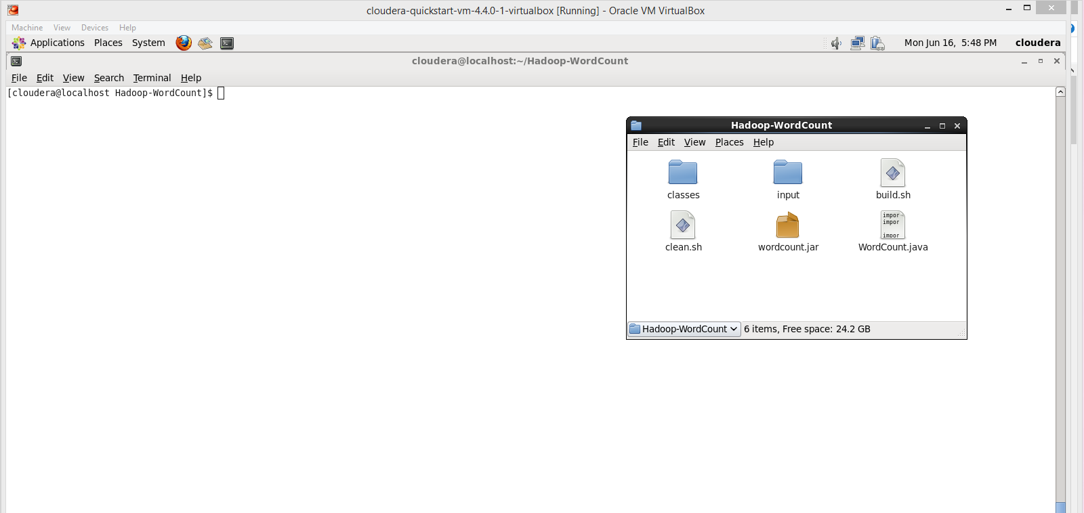

MapReduce Job

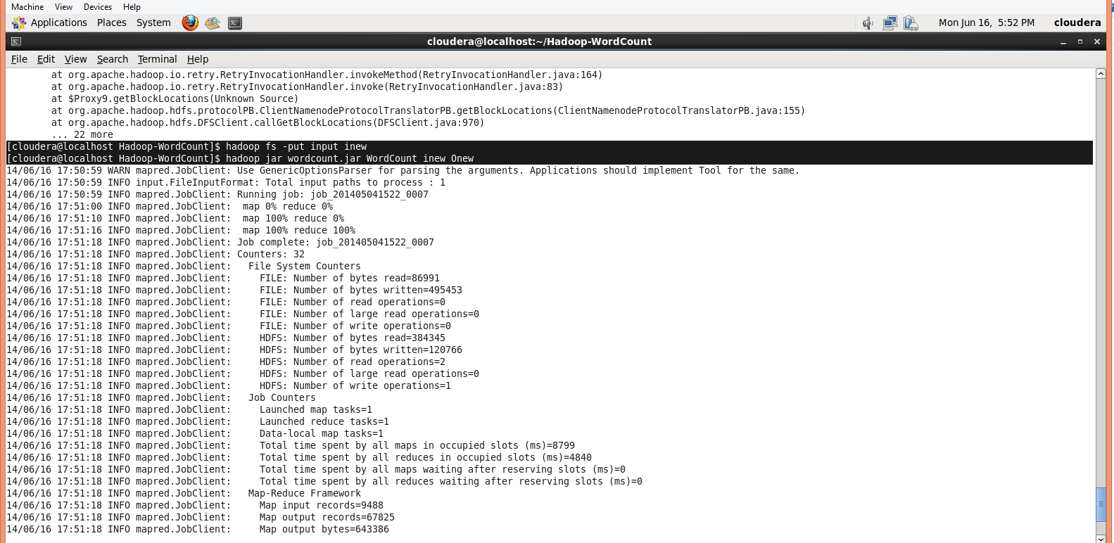

Output:

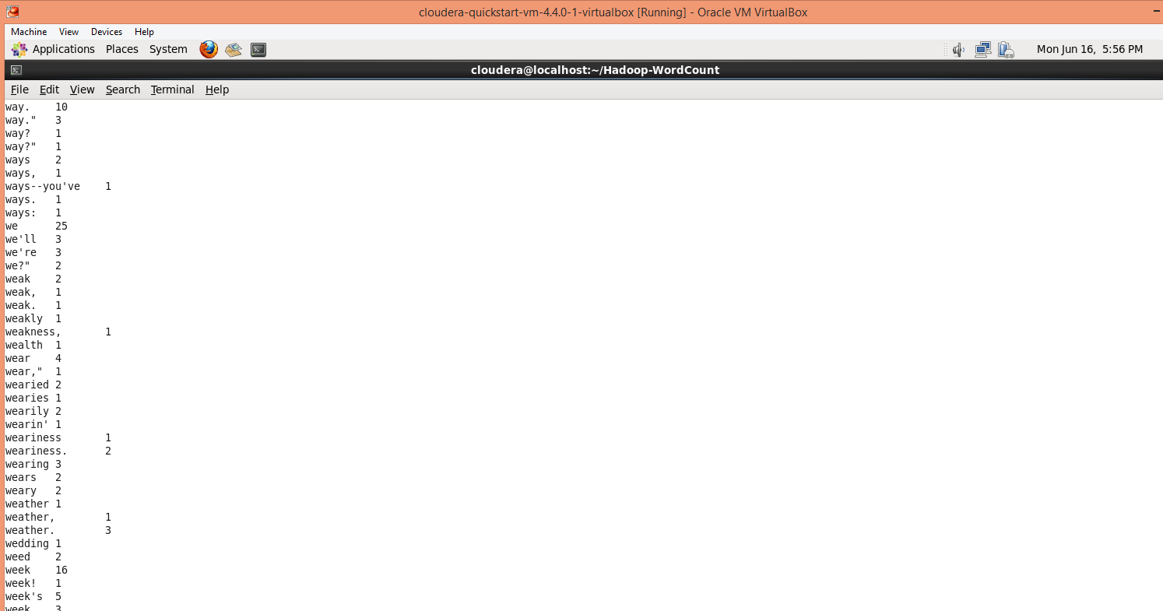

3. Glassfish server has already been installed.

Please find below the Restful webservice added to the server.

Windows:

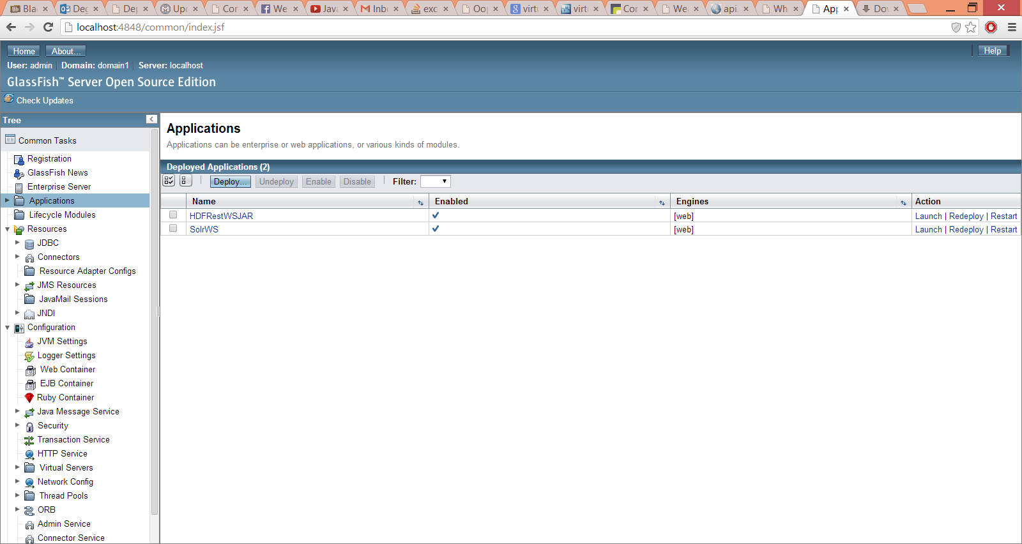

Linux:

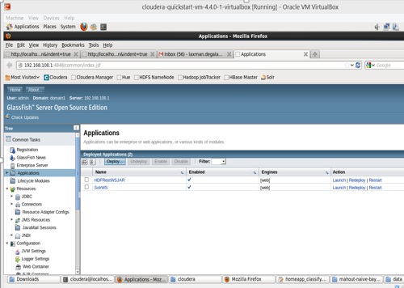

Task 3:

Github account created. Id: LaxmanDuttDegala

ScrumDo ID Created. Id: LaxmanDuttDegala